**CSE 5306, Distributed Systems**

**Fall 2020, Final Exam, Dec. 15 2020**

(Close-book, Close-notes, one doubled-side 8.5*11in help sheet allowed, Time: 2:00-4:30 pm)

NAME (print):____________________

*I have neither given nor received unauthorized assistance on this work.*

*Signed: Date:*

1) Please give the signature above. And, sign another separate attendance sheet, which will be forwarded around the classroom. If you do not sign it, there will be no your exam record and your solutions will not be graded.

2) This exam will be scored on the basis of 100 points. It is worth 35% of your course grade. Budget your time wisely.

4) Write all of your answers directly and **clearly** on the papers.

5) If you need to use back of the sheets, make sure that the continuations are marked clearly.

**Problem 1 (48 points)**

Please give **concise** answers to the following **8** questions.

1. Discuss the difference between consistency and coherence.

2. Discuss the trade-offs among the three virtual machine migration algorithms, i.e., stop-and-copy, pre-copy and post-copy migration.

3. Discuss the differences advantages and disadvantages of iterative name resolution and recursive name resolution, respectively.

4. Describe the four states in the MESI cache coherence protocol.

5. List the issues that should be addressed to virtualize X86 processors and the physical memory.

6. Discuss the differences between reliability and availability.

7. Discuss the differences between blocking and non-blocking communications in MPI.

8. Discuss the advantages and disadvantages of symmetric and asymmetric cryptography algorithms, respectively.

**Problem 2: Synchronization (10 points)**

Consider the following local events and communications between processes P0, P1, P2. Assume that in the Lamport logical clock and the vector clock both sending and receiving messages increment a corresponding logical clock by 1. Assume that the initial clock value at each process is zero. Answer the questions below.



a. Determine the Lamport logical time stamps for all the events (3pts)

b. Determine the vector clocks for all the events. Note that vector clocks cannot enforce a total order of events, thereby allowing the existence of concurrent events. Which event(s) are concurrent with event *f* ? (4pts)

c. Compared to Lamport’s logical clock, explain how vector clocks can be used to capture causality between events. (HINT: under what condition we can say an event happened before another?) To enforce causal communication, discuss what additional requirements are needed in the update of vector clocks and the delivery of events? (3pts)

**Problem 3 (10 pts)**

Assume a MapReduce cluster that consists of 32 nodes, each with 4 map slots and 2 reduce slots. The replication factor is set to 3 (there are three replicas of each block). Given a simple word count job with an input size of 320 GB, answer the following questions. Show your work.

a. Suppose the word count job processes the input data at a constant rate of 2MB/s. Determine a proper block size for the distributed file system considering the efficiency of map tasks as well as their recovery cost. Justify your choice. Given the configuration of the MapReduce cluster, determine how many map tasks will this job have and how many rounds/waves are needed to finish the map phase on this cluster? (4 pts)

b. How many reduce tasks should this job have. Justify your configuration. (2 pts)

c. What is the space requirement on hard disk to store the 160GB input data in the DFS? If each machine processes input data at a speed of 0.5 MB/s for a data sorting job, how should the DFS be adjusted? (4 pts)

**Problem 4: Distributed commit (7 pts)**

A sharded database uses two-phase commit to ensure that either all shard (replica) servers commit their part of each transaction, or none of them does. A database client executing a transaction sends the transaction’s puts and gets to the shard servers, and then uses a transaction coordinator (TC) to execute two-phase commit (2PC) for the transaction.

a. Based on the diagrams showing the working of the 2PC algorithm for both the TC and a participant shard server, briefly explain the steps of the two-phase commit. (3 pts)

b. Discuss how the 2PC algorithm handles failures of the TC and participants and the major drawback of the 2PC algorithm. (4 pts)

**Problem 5: Consistency models (10 pts)**

a. Is the following data store casually consistent? Explain your answer. If the data store is causally consistent (or inconsistent), add (or remove) one operation to make the store causally inconsistent (or consistent). (4pts)



b. Given the following code segments executing on two separate cores, what are the possible outputs of the codes (the values of r1 and r2) under sequential consistency (SC) and the total store order (TSO) consistency, respectively. For the output in TSO that is not possible in SC, explain how this output is possible under TSO. (6 pts)

|  |  |  |
| --- | --- | --- |
| Core-1 | Core-2 | Comments |
| S1: x = 1;  L1: r1 = y; | S2: y = 1;  L2: r2 = x; | /* Initially, x = 0 & y = 0*/ |

**Problem 6: Authentication protocol (6 pts)**

Study the following authentication protocol between Alice and Bob. Discuss and illustrate what type of attack can be launched against this protocol. Suggest a fix to the unsecure protocol. Design a new protocol that leverages a key distribution center to exchange the secret key between Alice and Bob.

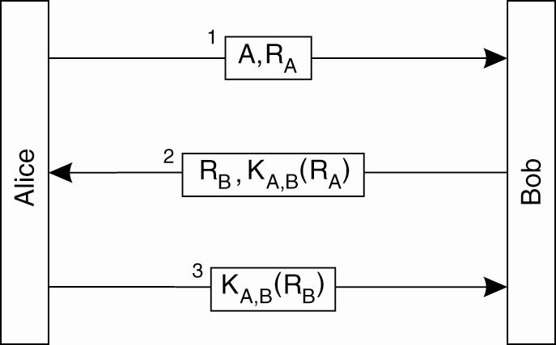

**Problem 7: Cache coherence (9 pts)**

Given the following cache coherent system with three processors, each with its private cache, explain the transition of cache line states at each step at each processor (draw the state transitions diagram for each private cache). For example, what is the state of the cache line that contains variable *u* at P1 at step 1? And what makes the cache line change to a different state at P1 at step 3? Assume that initially the private caches are all empty, calculate how many cache misses will occur after step 5 is completed.

